**BÀI THỰC HÀNH TUẦN 8**

**Họ và tên**: Nguyễn Khánh Hưng

**MSV:** 205748020110187

Câu 1:

import cv2

import matplotlib.pyplot as plt

img = cv2.imread(r'c:\Users\nguye\OneDrive\Pictures\night-digital-art-nighttime-moon-wallpaper.jpg')

x = int(input('Nhap toa do x: '))

y = int(input('Nhap toa do y: '))

h = int(input('Nhap chieu dai: '))

w = int(input('Nhap chieu rong: '))

crop = img[x : x + h, y : y + w ]

gray = cv2.cvtColor(crop, cv2.COLOR_BGR2GRAY)

gau = cv2.GaussianBlur(gray, (5,5), -1)

his = cv2.equalizeHist(gau)

plt.subplot(2,2,1), plt.imshow(img)

plt.title('Anh goc'), plt.xticks([]), plt.yticks([])

plt.subplot(2,2,2), plt.imshow(crop)

plt.title('Anh cat'), plt.xticks([]), plt.yticks([])

plt.subplot(2,2,3), plt.imshow(gau)

plt.title('Anh gaussian'), plt.xticks([]), plt.yticks([])

plt.subplot(2,2,4), plt.imshow(his)

plt.title('Anh histogram'), plt.xticks([]), plt.yticks([])

plt.show()

cv2.waitKey(0)

cv2.destroyAllWindows()

Kết quả:

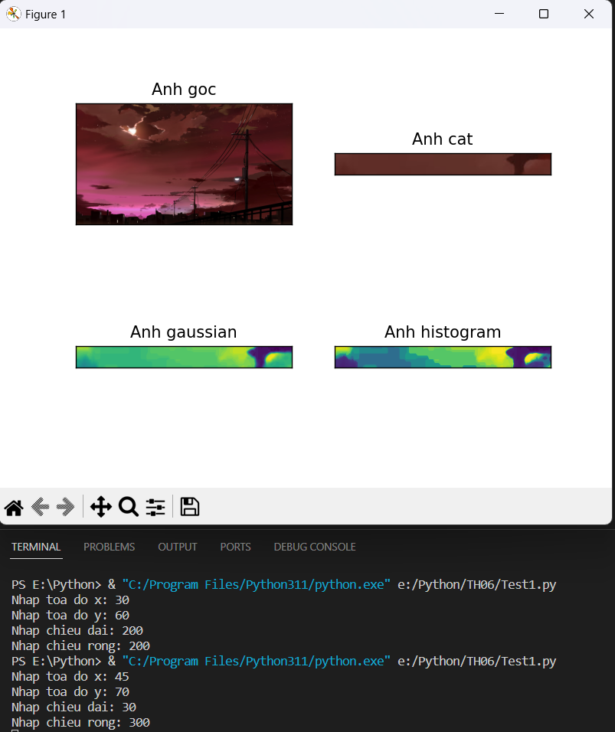

Câu 2:

import cv2

import numpy as np

img = cv2.imread(r'c:\Users\nguye\OneDrive\Pictures\night-digital-art-nighttime-moon-wallpaper.jpg')

up = 0

def get_up(pos):

    global up

    up = pos

down = 0

def get_down(pos):

    global down

    down = pos

cv2.namedWindow("NhiPhan")

cv2.createTrackbar('Can Duoi', 'NhiPhan', 0, 255, get_down)

cv2.createTrackbar('Can Tren', 'NhiPhan', 128, 255, get_up)

while True:

    thresh, img1 = cv2.threshold(img, down, up ,cv2.THRESH_BINARY)

    key = cv2.waitKey(1)

    kernel = np.ones((5, 5), np.uint8)

    img_erode = cv2.erode(img1, kernel, iterations= 1)

    cv2.imshow("NhiPhan", img_erode)

    if key == ord('q'):

        cv2.imwrite('KetQua.png', img_erode)

    if key == ord('f'):

        break

cv2.destroyAllWindows()

Kết quả:

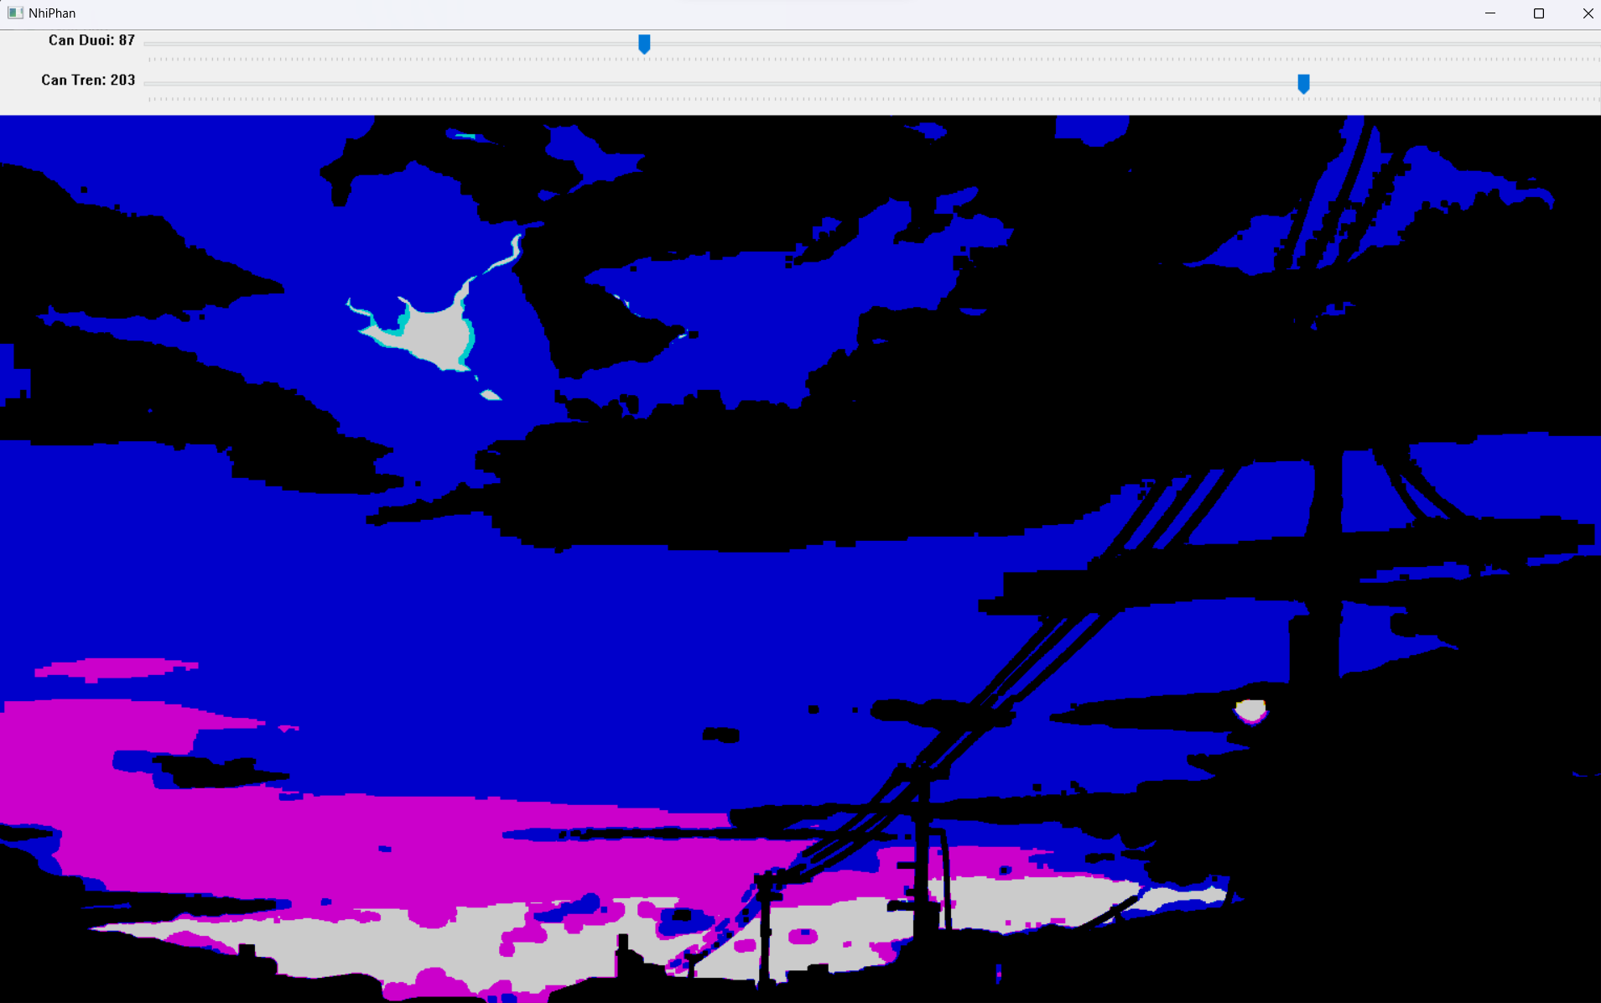

Câu 3:

import cv2

vid = cv2.VideoCapture(r'c:\Users\nguye\Videos\test.mp4')

while(vid.isOpened()):

    ret, frame = vid.read()

    if ret == True:

        frame_gray = cv2.cvtColor(frame, cv2.COLOR_BGR2GRAY)

        frame2 = cv2.convertScaleAbs(frame_gray, alpha= 2, beta=40)

        cv2.imshow('Video1', frame)

        cv2.imshow('Video', frame2)

        key = cv2.waitKey(1)

        if(key == ord('s')):

            cv2.imwrite('Vid.png', frame2)

        if(key == ord('q')):

            break

    else:

        break

vid.release()

cv2.destroyAllWindows()

Kết quả

